## CHERRY IN LINE

**Chapter 5**

**Findings, Results, and Analysis**

5.2 Electrical Audit

5.2.9 Electrical system design analysis

In accordance with Article 1.3 Electrical Plans and specifications of the Philippine Electrical Code 2017 Edition, Electrical design analysis shall be included and submitted separately together with the electrical plans. These includes the following :

(1) Branch circuits, sub-feeders, feeders, busways, and service entrance

(2) Types, ratings, and trip settings of overload protective device

(3) Calculation of voltage drops

(4) Calculation of short circuit current for determining the interrupting capacity of overcurrent protective device for residential, commercial and industrial establishment

(5) Protection coordination of overcurrent protective devices

(6) Arc-flash Hazard Analysis to determine the required personal protective equipment (PPE)

Arc flash Hazard Analysis is required and is intended for concerned parties to be informed and made aware of the importance of personal protective equipment (PPE) and its type for the flash hazard risk category determined by the analysis .

TABLE : ARC FLASH HAZARD RISK CATEGORIES AND PPE RATINGS

(APPENDIX H, PEC 2017)

|  |  |  |  |
| --- | --- | --- | --- |
| FLASH HAZARD RISK CATEGORY | RANGE OF CALCULATED INCIDENT ENERGY [cal/cm2] | MINIMUM PPE RATING  [cal/cm2] | CLOTHING REQUIRED |
| 0 | 0 ≤E ≤1.2 | N/A | 4.5-14.0 oz/yd2untreated cotton |
| 1 | 1.2 < E ≤ 4 | 4 | Flame Retardant (FR) shirt and Pants |
| 2 | 4 < E ≤ 8 | 8 | Cotton underclothing plus FR shirt and pants |
| 3 | 8 < E ≤ 25 | 25 | Cotton underclothing plus FR shirt, pants, overalls or equivalent |
| 4 | 25 < E ≤ 40 | 40 | Cotton underclothing plus FR shirt, pants, plus double layer switching coat and pants or equivalent |
| 5 | 40 < E ≤ 100 | 100 | Cotton underclothing plus FR shirt, pants, plus multi-layer switching suit or equivalent |

(1) Branch circuits, sub-feeders, feeders and service entrance

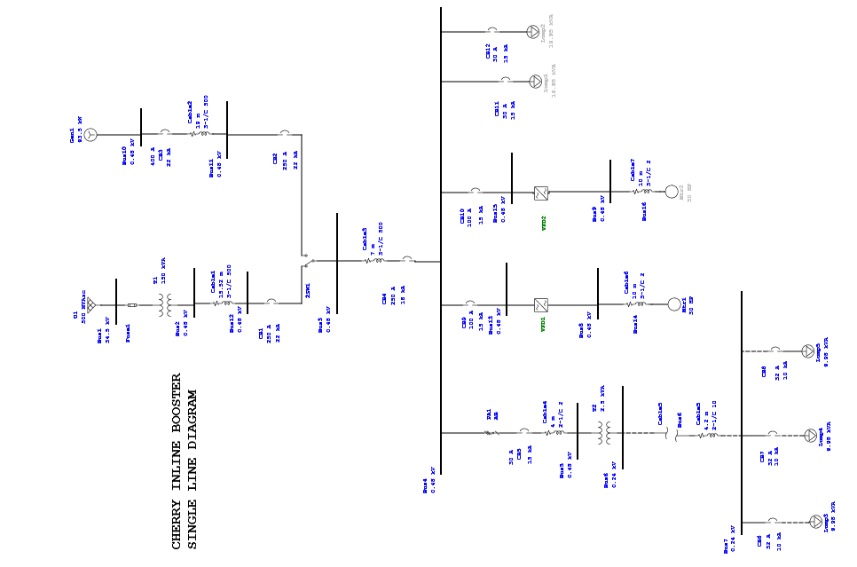

(2) Types, ratings, and trip settings of overload protective device

|  |  |  |  |  |  |  |  |
| --- | --- | --- | --- | --- | --- | --- | --- |
| **Protective Device Settings - Low Voltage Circuit Breaker with Thermal-Magnetic Trip Device** | | | | | | | |
| **LVCB ID** | **Manufacturer** | **Breaker** | | **Thermal** | | **Magnetic (Inst.)** | |
| **Model** | **Size** | **Setting** | **Trip (Amps)** | **Setting** | **Trip (Amps)** |
| CB4 | Fuji Electric | BW400EAG | 250 | Fixed | 250.000 | Fixed | 8 xIn |
| CB9 | Fuji Electric | BW125JAG | 100 | Fixed | 100.000 | Fixed | 8 xIn |
| CB10 | Fuji Electric | BW125JAG | 100 | Fixed | 100.000 | Fixed | 8 xIn |
| CB11 | Fuji Electric | BW32SAG | 32 | Fixed | 32.000 | Fixed | 8 xIn |
| CB12 | Fuji Electric | BW32SAG | 32 | Fixed | 32.000 | Fixed | 8 xIn |
| CB1 | Fuji Electric | BW400EAG | 250 | Fixed | 250.000 | Fixed | 8 xIn |

(3) Calculation of voltage drops

|  |  |  |  |  |  |  |  |  |  |  |  |
| --- | --- | --- | --- | --- | --- | --- | --- | --- | --- | --- | --- |
| **VOLTAGE DROP SUMMARY CHERRY IN LINE BOOSTER STATION** | | | | | | | | | | | |
| FEEDER CABLES VOLTAGE DROP | | | | | | | | | | | |
| Item | From | To | Wire Size, mm² | I | Length Meters | R Ω/305m | X Ω/305m | VD | %VD | REMARKS |
|
| 1 | Pole Mounted Transformer 50kVA,3Ø | ATS PANEL | 250.0 | 425 | 15.52 | 0.048 | 0.027 | 2.060 | 0.43% | WITHIN LIMTS |
| 2 | MTS PANEL | ECB 250A | 250.0 | 425 | 7 | 0.048 | 0.027 | 0.929 | 0.19% | WITHIN LIMTS |
| 3 | ECB 30A, 2P | DRY TYPE TRANSFORMER 2.5KVA | 5.5 | 40 | 4.2 | 1.2 | 0.063 | 1.324 | 0.55% | WITHIN LIMTS |
| 4 | DRY TYPE TRANSFORMER 2.5KVA, 1Ø | UPS PANEL | 5.5 | 40 | 4 | 1.2 | 0.063 | 1.261 | 0.53% | WITHIN LIMTS |
| 5 | MCCB 100A, 3P | 30HP MOTOR | 30.0 | 115 | 10 | 0.2 | 0.057 | 1.357 | 0.28% | WITHIN LIMTS |
|  | POLE MOUNTED TO 30 HP MOTOR | | | | | | | 3.417 | 0.71% | WITHIN LIMITS | |

(4) Calculation of short circuit current 3-PHASE & 1-PHASE

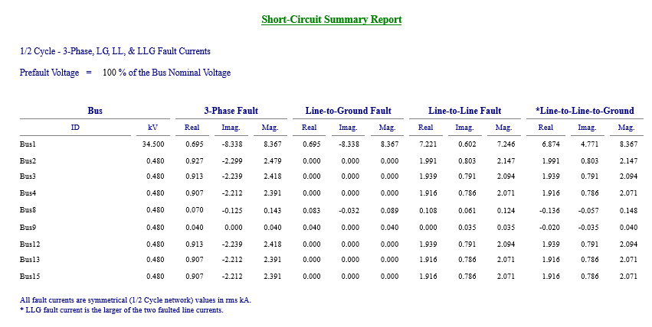

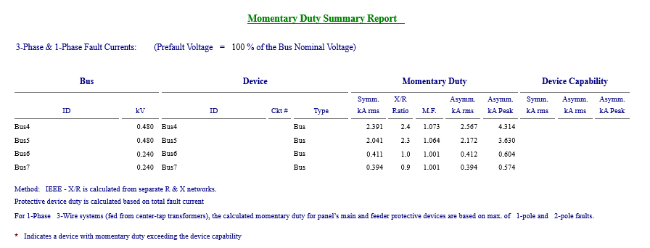

(5) Protection coordination of overcurrent protective devices

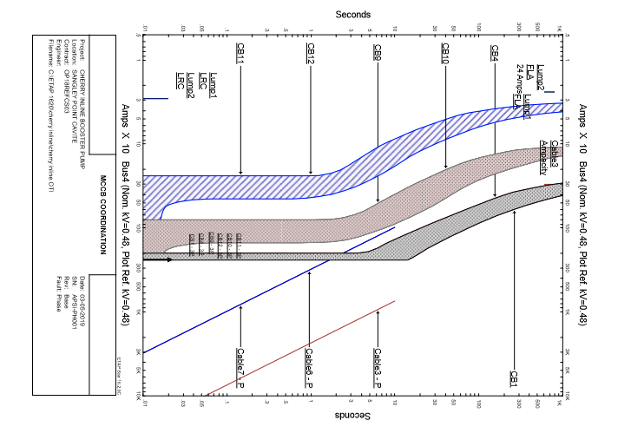

REMARKS: Partial coordination only for the main and feeder breakers. TCC of feeders crosses the TCC of enclosed circuit breaker upstream of the feeders.

(6) Arc-flash Hazard Analysis

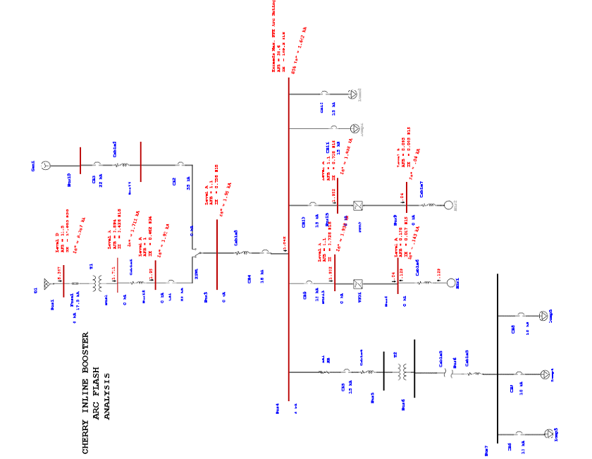

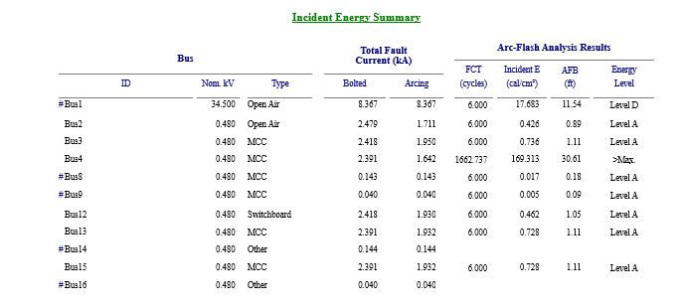

RECOMMENDATION :

According to the results of the Arc Flash Analysis, Cotton underclothing plus FR shirt, pants, plus multi-layer switching suit or equivalent should be worn when opening the cover of the MCC. Arc flash Boundary (AFB) is about 30.6 feet (9.33 meters). Contributors to the arc flash are the motor loads and the VFD’s.

An Arc flash label such as the one below should be placed on the MCC as per requirement of the Philippine Electrical code.

